Supporting Information for:
Bugs Pay for Days of Steady Reservoir Releases to Reduce Hydropeaking-Ecosystem Conflict
Moazzam Ali Rindª, and David E. Rosenbergª
ª Dept. of Civil and Environmental Engineering, Utah State University, Logan, UT, USA.
Contents of this file
Text S1 to S7
Figures S1 to S12
Tables S1 to S4
Introduction
The information in this document shares energy prices, hydropeaking value estimated from the energy prices, and observed hydrographs at Lees Ferry Gage. We also share equations for the Contract and Market price models. We share the model structure that includes input data, decision variables, constraints, outputs, and scenarios. We also share results from model validation across different months, results from offset scenarios, and market price sensitivity. Last, we discuss elevation change and its expected impact on hydropower production.
Text S1. Energy prices.
We used 2 different energy price data sets in this study.

- 2014 energy pricing data shared by managers early in our project (hereafter “2014 energy prices”; Palmer, personal communication, 2019; accessible at Rind and Rosenberg, 2026). We used these energy prices to validate the model against experimental releases observed in summer 2018
- The 2024 energy prices we derived from energy value and energy generation data Interior published and used in a supplemental environmental impact statement (SEIS) in spring 2024 to allow for water releases through Glen Canyon Dam’s low-level outlets—no hydropower generation—in summer and fall of 2024 to 2026 to lower release temperature with the goal to disrupt spawning of small mouth bass (hereafter “2024 energy prices”; Bair and Yackulic, 2024; USBR, 2024;Yackulic et. al, 2024; also accessible at Rind & Rosenberg, 2026). We used the 2024 energy prices in subsequent modeling, analysis, management recommendations, and discussion.

2014 Energy Prices. We received weekday hourly contract energy prices for the months of 2014 from the Western Area Power Authority (WAPA) (Palmer, personal communication, 2019; accessible at Rind and Rosenberg, 2026). As an example, Figure S1 shows weekday August 2014 contract prices by hour of the day. We transformed the hourly price data into prices for each day type and period. First, we averaged the 15-minute hydrograph data from the Lees Ferry gauge to get hourly release values. We then used the hydropower generation formula (Eq. S1) to calculate hourly energy generation. We multiplied the estimated hourly energy generation by the hourly energy price to estimate hydropeaking value generated per hour. Finally, we divided the monthly hydropeaking value for each high and low flow period of each day type by the number of hours for each period of each day type (16 hours on-peak and 8 hours off-peak). This division estimated the average energy price for each day type and period. August is the month with the highest energy prices. Because we only had weekday energy prices, we followed guidance from WAPA and generated Saturday and Sunday off-peak prices by setting them to the average weekday off-peak price. We set the Sunday on-peak price to the Sunday off-peak price and set the Saturday on-peak price to the average of the weekday and Sunday on-peak prices. Thus, in this data set, the average off peak price was the same for weekdays, Saturdays, and Sundays (Table S1). We generated market prices by adding a uniform $5/MWh premium to the 2014 contract prices across all days and pricing periods.
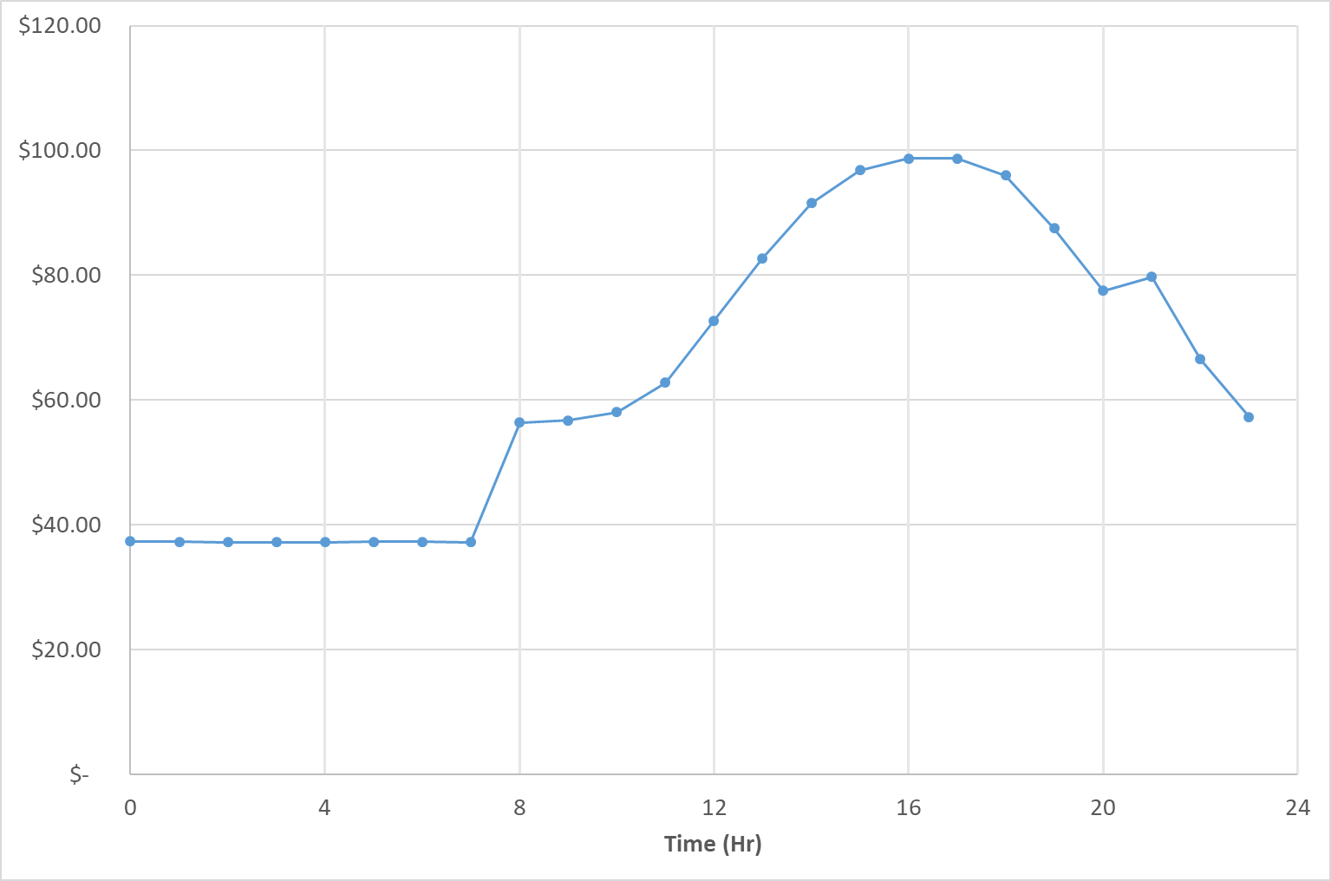
Fig. S1. August hourly contract energy prices.
Table S1. 2014 period average contract energy prices by month, day type, and period used in model validation and sensitivity analysis ($/MWh)
Estimated 2024 Energy Prices. Yackulic et al, (2024) and Bair & Yackulic (2024) reported release (cfs), energy generation (MWh), and economic value of releases (nominal $ per hour) by hour for each hour of the month and each month of the year for years 2024 to 2026. They replicated week 1 data of each month to weeks 2, 3, and 4. Thus, our analysis focused on the first week of each month. Since Bair & Yackulic (2024) did not provide the underlying energy price data, we estimated 2024 energy prices by dividing reported energy value ($) by generation (MWh). Figure S2 shows the resulting time-series of hourly prices for the first weeks of June, July, August, and September. Next, we identified the 80 weekday on-peak hours for the 1st week, 40 weekday off-peak hours for the 1st week, 16 weekend on-peak hours for the 1st week, and 16 weekend off-peak hours for the 1st week. Finally, we averaged prices across each day type and period to obtain average prices for on- and off-peak weekdays and weekends (Figure S3; Table S2). We added a uniform $5/MWh premium to the 2024 energy prices across all days and pricing periods. Further analysis and visualization of the estimated 2024 energy price data, including for March, April, May, and October, are available at Rind and Rosenberg (2026).
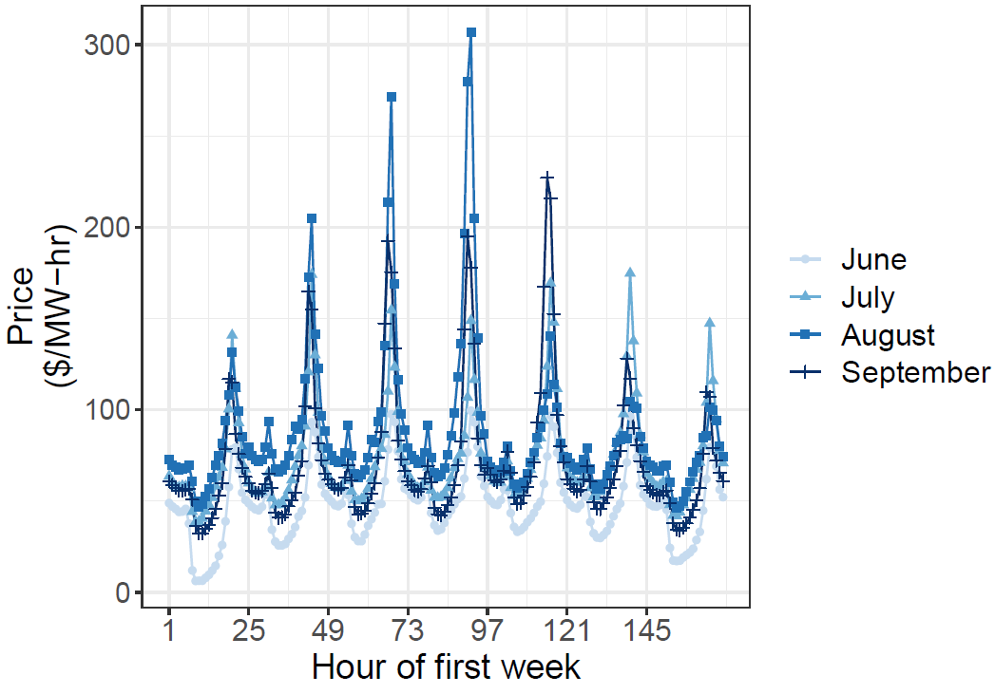
Fig. S2. Time-series of estimated 2024 energy prices for the first week of June, July, August, and September (estimated from Bair and Yackulic, 2024; Yackulic et al, 2024).
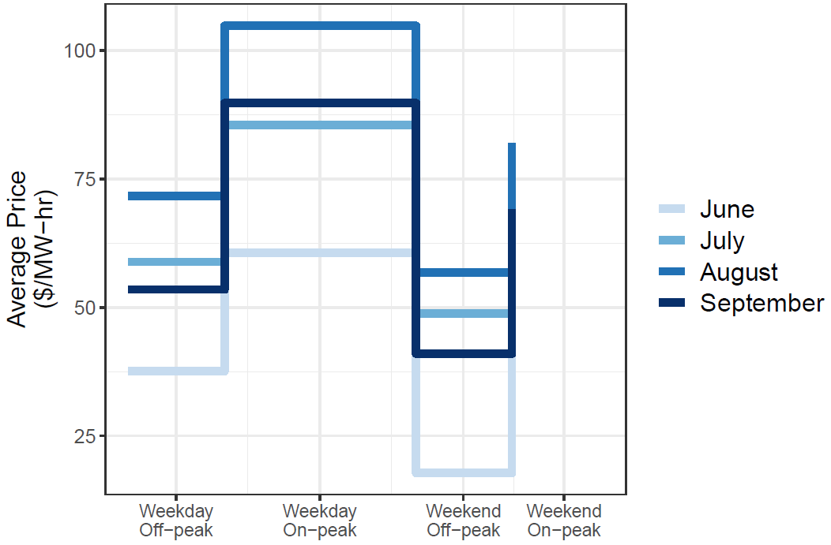
Fig. S3. Estimated period average energy prices in 2024 for the first week of June, July, August, and September (estimated from Bair and Yackulic, 2024; Yackulic et al, 2024).
Table S2. Estimated 2024 average energy prices by month, day type, and period ($/MWh)
Text S2. Observed hydrographs at Lees Ferry Gage.
We looked through multiple monthly hydrographs across various pre-bug flow years and observed a similar pattern for operations—weekday on and off-peak periods and slightly lower peaks during weekend. Here, we present a few pre-bug flows observed hydrographs of August (Figure S4–S6) from different years with various monthly flow volumes.
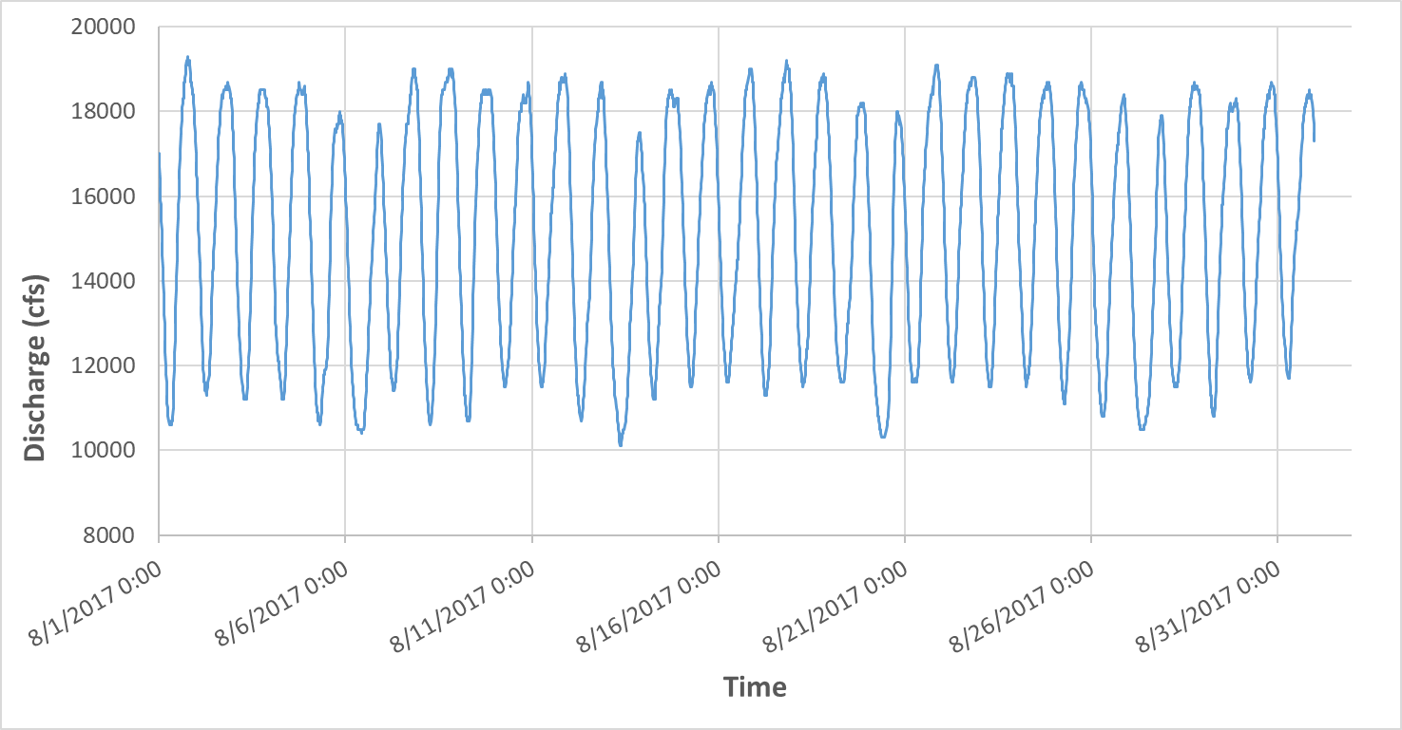
Fig. S4. Pre-bug flow observed hydrograph (USGS 09380000). August 5, 6, 12, 13, 19, 20, 26, and 27 were weekends in 2017. Total monthly volume was ~0.94 Ac-ft.
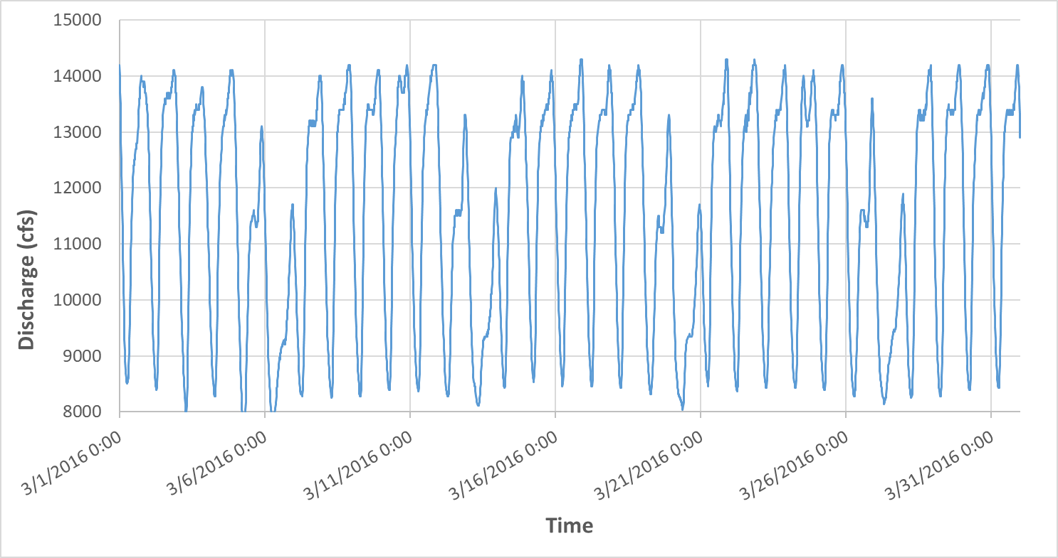
Fig. S5. Pre-bug flow observed hydrograph (USGS 09380000). March 5, 6, 12, 13, 19, 20, 26, and 27 were weekends in 2016. Total monthly volume was ~0.72 Ac-ft.
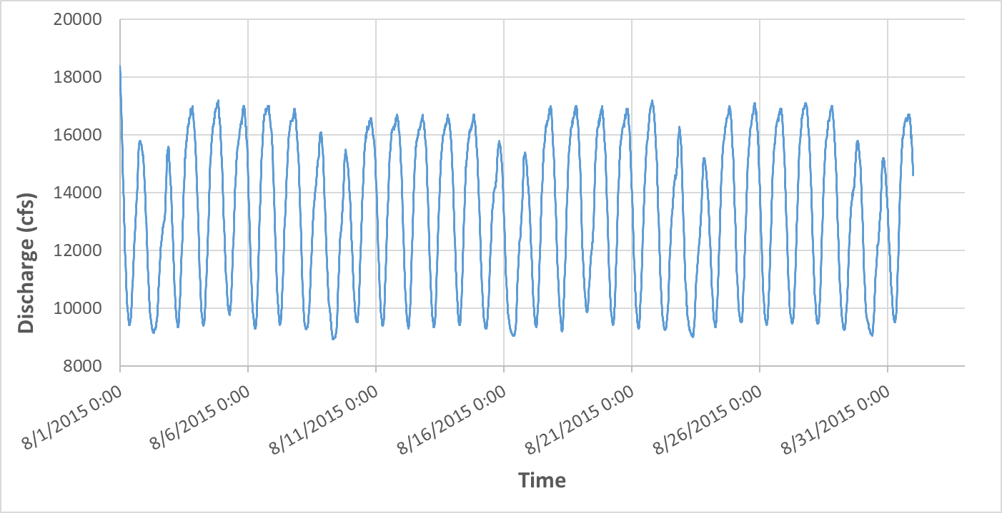
Fig. S6. Pre-bug flow observed hydrograph (USGS 09380000). August 1, 2, 8, 9, 15, 16, 22, 23, 29, and 30 were weekends in 2015. Total monthly volume was ~0.83 Ac-ft.
Text S3. Model formulation.
The model structure includes input data, decision variables, constraints, outputs, and scenarios (Fig. S7).
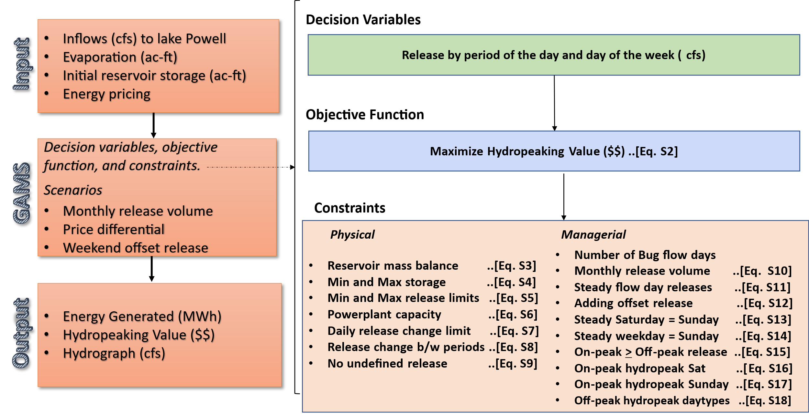
Fig. S7. Model structure.
The energy prices and observed hydrographs supported the assumption of 2 weekly flow patterns f (hydropeak or steady), 3 day types d (Sunday, Saturday, and Weekday), and 2 periods p per day (on-peak or off-peak). This grouping reduced 744 hourly flow values for a month (24 hours per day * 31 days per month = 744 hours per month) into 12 sub-daily characteristic releases, Release _{f,d,p} [cfs]. Here, 2 flow patterns p x 3 day types d x 2 periods p = 12 characteristic releases per month.
We introduced and calculated the state variable energy generation (Energy_Gen_{f,d,p} [MWh per month]) for each flow pattern f, day type d, and period p:
Energy_Gen _{f,d,p} = Release _{f,d,p} * Duration _{p} * 0.03715, ∀ f, d, p. (eq. S1)
Where Release was defined previously, Duration_{p} is the duration of each period p [hr], and 0.03715 is the typical energy generation coefficient [MW-hr per 1 cfs of release].
As discussed in the main text, we opted to maximize hydropeaking value using the constraint method. The objective function was:
Hydropeaking Value = ∑_{f,d,p} Energy_Gen _{f,d,p} * 𝑃𝑟𝑖𝑐𝑒_{𝑑,𝑝} * Num_Days _{f,d} (eq. S2)
Here, Price_{d,p} [$/MW-hr] represents the energy price type during each day type d and period of the day p. Specifying the number of days (Num_Days _{f,d}) for each flow pattern f and day type d allowed the model to vary the number of steady low flow days per month from 0 to 31 and define the order that day types d switched from a hydropeak to steady flow pattern (e.g., first Sundays, then Saturdays, then Weekdays). In all cases, ∑_{f,d} Num_Days _{f,d} equals the number of days in the month. For example, if there are 10 steady flow days in a month (e.g., August) that starts on a Monday, then the model will place the first 4 steady days on Sundays first because contract energy prices on Sunday are lowest, then next 4 steady flow days on Saturdays, and the remaining 2 steady days on weekdays. The 21 remaining days of the month fall on weekdays have a flow pattern of hydropeak (Table S3).
Table S3. Number of days per month for each flow pattern f and day type d for a month with 31 days and 10 days of steady low releases.
Day type | Flow pattern
 | Steady | Hydropeak
Sunday | 4 | 0
Saturday | 4 | 0
Weekday | 2 | 21
In contrast, a scenario with zero steady low flow days per month means the model will decide releases for all weekends and weekdays with flow pattern hydropeak while the number of days for flow pattern steady are zero (Table S4).
Table S4. Number of days per month for each flow pattern f and day type d for a month with 31 days and 0 days of steady low releases.
Day type | Flow pattern
 | Steady | Hydropeak
Sunday | 0 | 4
Saturday | 0 | 4
Weekday | 0 | 23
Equations S1 and S2 are subjected to physical and managerial constraints. Physical constraints include:
- Reservoir mass balance. The mass balance was applied at the reservoir on a monthly time scale.
Storage = Initstorage + Inflow - Released_vol - evap (eq. S3)
Where Initstorage is initial reservoir storage [ac-ft], Inflow is monthly volume inflow to the reservoir [ac-ft]. The inflow volume is the product of average inflow [cfs] converted into [ac-ft/hr] (i.e., 1 cfs = 0.083 ac-ft/hr), duration of periods [hrs], and number of days in a month. Released_vol is the total volume of water released in the month [ac-ft], and evap is the volume of water evaporated during the month [ac-ft].
- Reservoir storage limits. Storage should not go below a minimum storage volume minstorage [ac-ft] or exceed the maximum storage capacity maxstorage [ac-ft].
minstorage ≤ Storage ≤ maxstorage (eq. S4)
The minimum live storage required for hydropower generation at Glen Canyon Dam was 4 million-acre feet [MAF] (3490 ft msl), and the maximum live storage was 25 MAF (3710 ft msl).
- Release limits. During any period p on any day type d, reservoir releases should not go below a minimum release [cfs] or exceed a maximum release [cfs]. The minimum release was 8,000 cfs (approx. minimum required for hydropower generation), and the maximum release was the turbine capacity at Glen Canyon Dam, i.e., 31,500 cfs.
MinRel ≤ Release _{f,d,p} ≤ maxRel ∀ f,d,p (eq. S5)
- Maximum Energy Generation limit. During any time period, the energy generated should not exceed the turbines’ maximum generation capacity [MWh].
Energy_Gen_{f, d, p} ≤ 1320 × Duration_{p} ∀ f,d,p (eq. S6)
The maximum hydropower generation capacity of Glen Canyon Dam is 1,320 MW (USBR, 2019).
- Allowable change in release between periods. The maximum allowable change between periods is defined in the Long-Term Experimental Management Plan (LTEMP, 2016) as 8,000 cfs. The change in release between any two periods should not exceed Daily_RelRange (i.e., 8000 cfs).
Release_{f,d,pHigh} – Release_{f,d,pLow} ≤ Daily_RelRange ∀ f,d (eq. S7)
- Allowable change in release between periods of neighboring days. Release change between on-peak periods of current day and off-peak period of next day should not exceed Daily_RelRange (i.e., 8000 cfs).
Release_{f,d,pHigh} – Release_{f,d+1,pLow} ≤ Daily_RelRange ∀ f,d (eq. S8)
- No release during undefined flow pattern. This constraint ensures that when a particular flow pattern and day type (e.g., hydropeak Saturday) is not required in a hydrograph, the flow during that pattern and day type is zero.
Release _{f, d, p} = 0 (eq. S9)
The managerial constraints include:
- Total monthly release volume. The sum of releases for all flows patterns, day types, and periods must equal the specified monthly release volume.
TotMonth_volume=∑_{f,d,p} Release_{f,d,p}* Con * Duration_{p} * Num_Days _{f,d} (eq. S10)
Con is a conversion factor from cfs to ac-ft per hour (i.e., 1 cfs = 0.083 ac-ft/hr).
- Same on- and off-peak release on steady flow days. On a steady flow day, the model should make the same releases during both on- and off-peak periods.
Release_{Steady,d,pHigh} = Release_{Steady”,d,pLow”} ∀ d (eq. S11)
- Add offset release as the difference between the steady low Sunday release and weekday low hydropeaking release. This offset was added because with zero offset (H0, 0 cfs), downstream sites saw progressively smaller benefits due to the weekday peak releases converging to a high flow value. Eggs laid on weekdays were still desiccated when the trough of the weekend steady low release passed downstream (Kennedy, personal communication, 2021). The offset release value was based on the results of egg-laying optimization models that sought to maximize canyon-wide egg-laying benefits (especially at downstream locations where native fish populations are high). The offset releases are still experimental. A 1000 cfs (H1000) offset was tested in 2018, and 750 cfs (H750) during 2019-2020.
Release_{Steady,Sunday,pLow} = Release_{Hydropeak,Weekday,pLow} + Offset_Rel (eq. S12)
Where Offset_Rel [cfs] is a pre-defined offset release value.
- Same flows on steady Saturdays and Sundays.
Release_{Steady,Saturday, p} = Release_{Steady,Sunday,p} ∀ p (eq. S13)
- Steady weekday release equals the release on steady Saturday and Sunday.
Release_{Steady,Weekday,p} = Release_{Steady,Sunday p} ∀ p (eq. S14)
- On-peak release on a Hydropeak day should be equal to or greater than off-peak release.
Release_{Hydropeak d,pHigh} ≥ Release_{Hydropeak,d,pLow} ∀ d (eq. S15)
- On-peak hydropeak Saturday release equals 2,000 cfs less than on-peak hydropeak weekday to follow the pre-bug flow hydrograph where there was ~2,000 cfs lower release during on-peak Saturdays and Sundays in comparison to on-peak weekdays. This difference may be that there was lower hydropower demand on weekend.
Release_{Hydropeak,Saturday,pHigh} = Release_{Hydropeak,Weekday,pHigh} - 2000 (eq. S16)
- On-peak hydropeak Sunday release equals 2,000 cfs less than on-peak hydropeak weekday.
Release_{Hydropeak,Sunday,pHigh} = Release _{Hydropeak,Weekday,pHigh} - 2000 (eq. S17)
Constraints n and o (Eq. S16 and S17) mimic a pre-Bug Flow Experiment hydrograph (e.g., Fig S2, S3, and S4). Without constraints n and o, the model was expected to generate the maximum possible hydropeaking value by saving water during hydropeak Saturdays and Sundays (minimum release). Nevertheless, the minimum release would have created an energy deficit and forced WAPA to purchase energy from the market.
- Same off-peak releases for hydropeak day types. Off-peak releases were assumed identical across hydropeaking day types (Saturday, Sunday, and weekday). The consistent off-peak energy prices supported the assumption.
Release_{Hydropeak,Saturday,pLow} = Release_{Hydropeak,Sunday,pLow} = Release_{Hydropeak,Weekday,pLow} (eq. S18)
Text S4. Additional equations for market price model.
The market price model represents situations in which hydropower generation is less than the contracted energy amount, requiring producers to purchase deficit energy at the market price.
The setup required two sub-models:
- Sub-model for zero days of steady low flow
This sub-model has a hydropeaking flow pattern on all day types (Saturday, Sunday, and weekday) and all periods. Flows for all days and periods for the steady flow pattern are zero. This sub-model generates the maximum possible hydropeaking value.
Revenue_ZeroSteadyDays = ∑_{d,p}(𝑅𝑒𝑙𝑒𝑎𝑠𝑒_{𝐻𝑦𝑑𝑟𝑜𝑝𝑒𝑎𝑘,𝑑,𝑝} × 𝐷𝑢𝑟𝑎𝑡𝑖𝑜𝑛_{𝑝} × 0.03751 × 𝐸𝑛𝑒𝑟𝑔𝑦_𝑃𝑟𝑖𝑐𝑒_{𝑑,𝑐𝑜𝑛𝑡𝑟𝑎𝑐𝑡,𝑝}) × 𝑁𝑢𝑚_𝐷𝑎𝑦𝑠_{𝐻𝑦𝑑𝑟𝑜𝑝𝑒𝑎𝑘,𝑑} (eq. S19)
- Sub-model when the number of steady low flow days is greater than zero
This sub-model uses combinations of contract and market prices to calculate hydropeaking value when the number of days of steady flow is greater than zero (main text, Figure 3).

We used observed releases (Observed_Rel_{𝑑,}) as a reference to decide the case of either surplus or deficit energy.

SurplusDeficitEnergy_{flowpattern,d,p} = {MinimumRelease_{flowpattern,𝑑,𝑝} × 𝐸𝑛𝑒𝑟𝑔𝑦_𝑃𝑟𝑖𝑐𝑒_{𝑑,𝑐𝑜𝑛𝑡𝑟𝑎𝑐𝑡,𝑝} + (𝑅𝑒𝑙𝑒𝑎𝑠𝑒_{flowpattern,𝑑,𝑝} – Observed_Rel_{𝑑,𝑝}) × 𝐸𝑛𝑒𝑟𝑔𝑦_𝑃𝑟𝑖𝑐𝑒_{𝑑,Market,𝑝}} × 𝐷𝑢𝑟𝑎𝑡𝑖𝑜𝑛_{𝑝} × 0.03751 × Num_Days_{Hydropweak,d} (eq. S20)

The MinimumRelease refers to the lower value of the observed or modeled releases in flowpattern on day type d and period p (eqs. S21 and S22).

MinimumRelease_{flowpattern} ≤ 𝑅𝑒𝑙𝑒𝑎𝑠𝑒_{flowpattern,,} ∀ flowpattern, d, p (eq. S21)

MinimumRelease_{flowpattern,,} ≤ Observed_Rel_{𝑑,𝑝} ∀ flowpattern, d, p (eq. S22)

Here, releases up to the MinimumRelease are valued and sold at the contract price (first term in eq. S20). When the Release is greater than the Observed_Rel, the difference is positive, valued, and sold at the market price (positive value of second term in eq. S20; surplus energy). When the Observed_Rel is greater than the Release, the difference is negative, valued, and purchased at the market price (negative value of second term in eq. S20; deficit energy).
Text S5. Model validation.
We compared sub-daily releases from the Contract model against observed (i.e., 15-min hydrograph) and averaged hourly datasets (e.g., Fig. S8). Total release volume was held constant across all hydrographs. We then compared the daily energy generation (MWh) from the hydrographs (e.g., Fig. S9). The hourly scenario was designed to directly apply the 2014 energy pricing from WAPA (Text S1). We validated the model for months of 2018 and the results are gathered in Table S5.
We initially named the contract model the "Saturday–Sunday–Weekday" model, a naming convention that helped distinguish it from other day-type formulations (such as weekend–weekday) evaluated during model development. Once we identified the suitable day-type template, it became easier to differentiate model versions by contract and market.
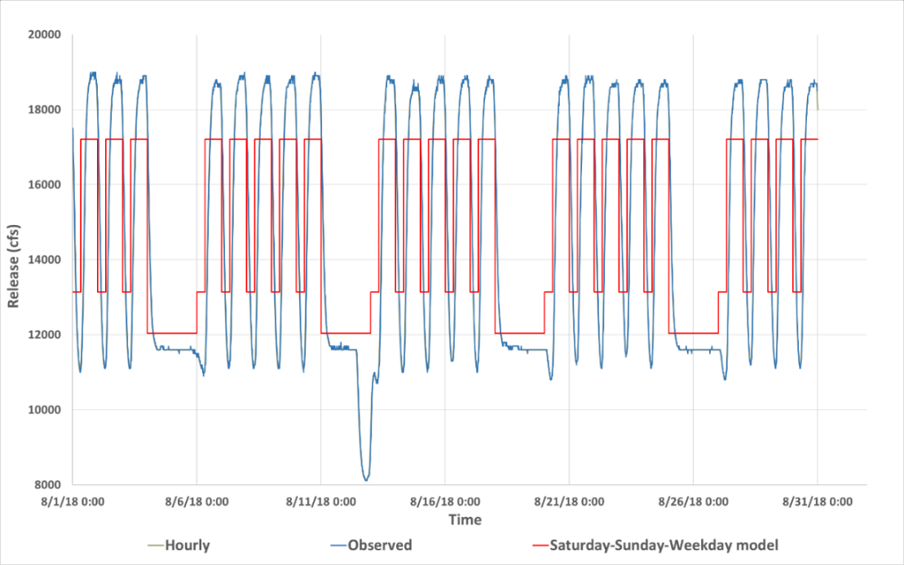
Fig. S8. Releases for August 2018: Observed (blue) vs Saturday-Sunday-Weekday (red).
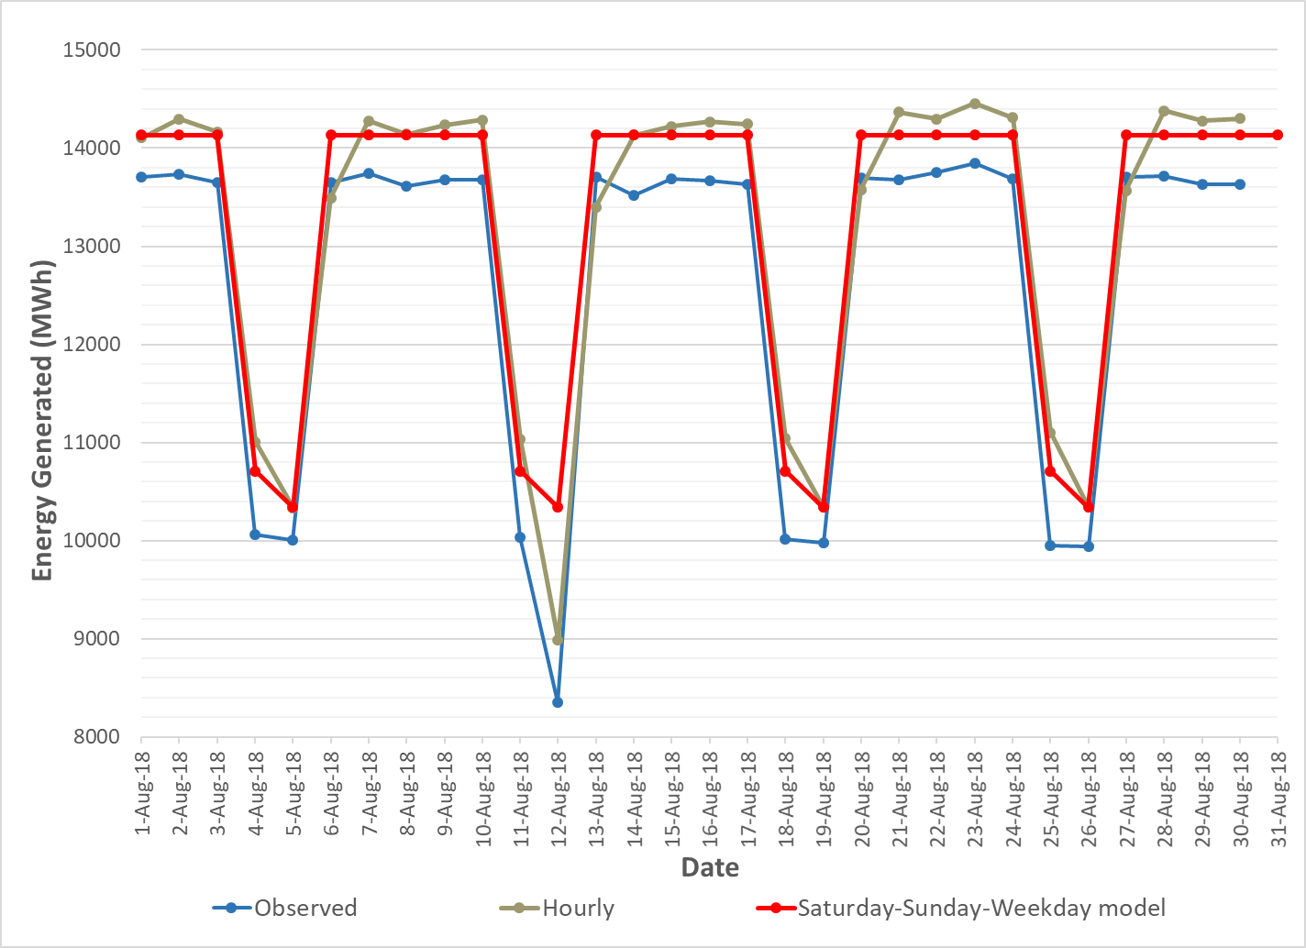
Fig. S9. Daily energy generation: observed (blue) vs hourly (green) vs Saturday-Sunday-Weekday model (red).
Table S5. Validation results for months of the year. The model was calibrated using 2014 energy prices because these were the only pricing data during model development.
March 2018
Scenario |  | Released volume  (Ac-ft/ Month) | Energy Generated (MWh) | % Error in Energy generated relative to observed | Hydropeaking value ($) | Energy Prices used ($/MWh)
1 | Observed | 838,771 | 363,797
2 | Hourly | 838,771 | 375,426 | 3.2% | $19,497,014 | Hourly prices by WAPA
3 | Weekend-Weekday model | 838,771 | 375,426 | 3.2% | $19,497,050 | Weekday On-peak = 58.643 & Off-peak = 44.37 and Weekend = 44.37
4 | Saturday-Sunday-Weekday  model | 838,771 | 375,426 | 3.2% | $19,787,571 | Sunday, off-peak Saturday & Weekday = 44.37, on-peak Saturday = 51.5, and on-peak Weekday = 58.643
April 2018
1 | Observed | 740,527 | 318,194
2 | Hourly | 740,527 | 331,453 | 4.2% | $15,548,812 | Hourly prices by WAPA
3 | Weekend-Weekday model | 740,527 | 331,453 | 4.2% | $15,548,840 | Weekday On-peak = 55.05 & Off-peak = 38.24 and Weekend = 38.24
4 | Saturday-Sunday-Weekday  model | 740,527 | 331,453 | 4.2% | $15,805,642 | Sunday, off-peak Saturday & Weekday = 38.24, on-peak Saturday = 46.70, and on-peak Weekday = 55.05
May 2018
1 | Observed | 731,979 | 318,486
2 | Hourly | 731,979 | 327,627 | 2.9% | $15,759,215 | Hourly prices by WAPA
3 | Weekend-Weekday model | 731,979 | 327,627 | 2.9% | $15,759,222 | Weekday On-peak = 57.16 & Off-peak = 35.96 and Weekend = 35.96
4 | Saturday-Sunday-Weekday  model | 731,979 | 327,627 | 2.9% | $15,993,079 | Sunday, off-peak Saturday & Weekday = 35.96, on-peak Saturday = 46.56, and on-peak Weekday = 57.16
June 2018
1 | Observed | 784,406 | 343,202
2 | Hourly | 784,406 | 351,093 | 2.3% | $18,308,023 | Hourly prices by WAPA
3 | Weekend-Weekday model | 784,406 | 351,093 | 2.3% | $18,308,089 | Weekday On-peak = 63.52 & Off-peak = 37.70 and Weekend = 37.70
4 | Saturday-Sunday-Weekday  model | 784,406 | 351,093 | 2.3% | $18,695,476 | Sunday, off-peak Saturday & Weekday = 37.70, on-peak Saturday = 50.61, and on-peak Weekday = 63.52
July 2018
1 | Observed | 880,790 | 383,680
2 | Hourly | 880,790 | 394,233 | 2.8% | $25,694,899 | Hourly prices by WAPA
3 | Weekend-Weekday model | 880,790 | 394,233 | 2.8% | $25,694,908 | Weekday On-peak = 80.08 & Off-peak = 46.55 and Weekend = 46.55
4 | Saturday-Sunday-Weekday  model | 880,790 | 394,233 |  | $26,150,218 | Sunday, off-peak Saturday & Weekday = 46.55, on-peak Saturday = 63.31, and on-peak Weekday = 80.08
August 2018
1 | Observed | 914,428 | 392,938
2 | Hourly | 914,428 | 409,289 | 4.2% | $27,235,815 | Hourly prices by WAPA
3 | Weekend-Weekday model | 914,428 | 409,289 | 4.2% | $27,235,936 | Weekday On-peak = 79 & Off-peak = 49.70 and Weekend = 49.70
4 | Saturday-Sunday-Weekday  model | 914,428 | 409,289 | 4.2% | $27,641,618 | Sunday, off-peak Saturday & Weekday = 49.70, on-peak Saturday = 64.35, and on-peak Weekday = 79
September 2018
1 | Observed | 693,733 | 288,363
2 | Hourly | 693,733 | 310,508 | 7.7% | $18,918,733 | Hourly prices by WAPA
3 | Weekend-Weekday model | 693,733 | 310,508 | 7.7% | $18,918,852 | Weekday On-peak = 70.01 & Off-peak = 52.19 and Weekend = 52.19
4 | Saturday-Sunday-Weekday  model | 693,733 | 310,508 | 7.7% | $19,241,731 | Sunday, off-peak Saturday & Weekday = 52.19, on-peak Saturday = 61.1, and on-peak Weekday = 70.01
October 2018
1 | Observed | 653,338 | 268,334
2 | Hourly | 653,338 | 292,428 | 9.0% | $16,679,721 | Hourly prices by WAPA
3 | Weekend-Weekday model | 653,338 | 292,428 | 9.0% | $16,679,743 | Weekday On-peak = 65.24 & Off-peak = 47.17 and Weekend = 47.17
4 | Saturday-Sunday-Weekday  model | 653,338 | 292,428 | 9.0% | $16,924,578 | Sunday, off-peak Saturday & Weekday = 47.17, on-peak Saturday = 56.20, and on-peak Weekday = 65.24
Text S6. Releases, offset, market price sensitivity, and elevation scenarios with 2024 energy prices.
The number of steady low flow days controlled the on- and off-peak releases (Fig. S10). Until 8 steady low flow days, the model reduced off-peak releases on hydropeak days and steady low flow releases. The saved water was released during on-peak weekdays to maximize overall hydropeaking value.
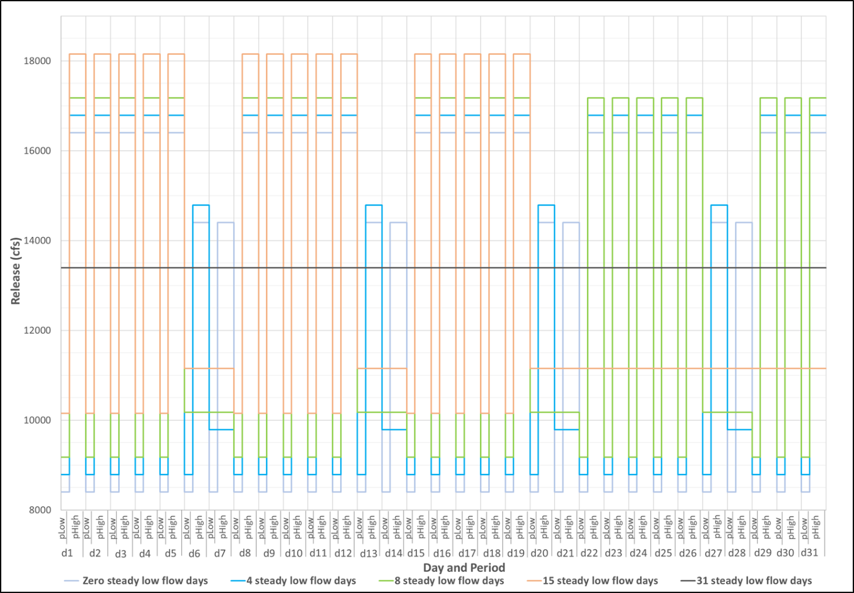
Fig. S10. Monthly hydrographs from contract model for August with total release volume of 0.83 MAF, 1000 cfs offset release, and scenarios of different number of days of steady releases. d1 is a Monday.
We tested impacts of different offset releases on the tradeoff curves and found minimal changes (Fig. S11).
A $30/MWh premium over the estimated 2024 energy prices shifted tradeoff curves only slightly to the right relative to a $5/MWh premium (Fig. S12).
We also estimated the effects of elevation changes on energy production (Table S6). In these estimates, we assumed a constant turbine efficiency (0.9) across depths in the power equation for the hydropower plant. The change in energy generation due to elevation change was less than 70 MWh per month (0.02% of observed energy generated in Table S5).
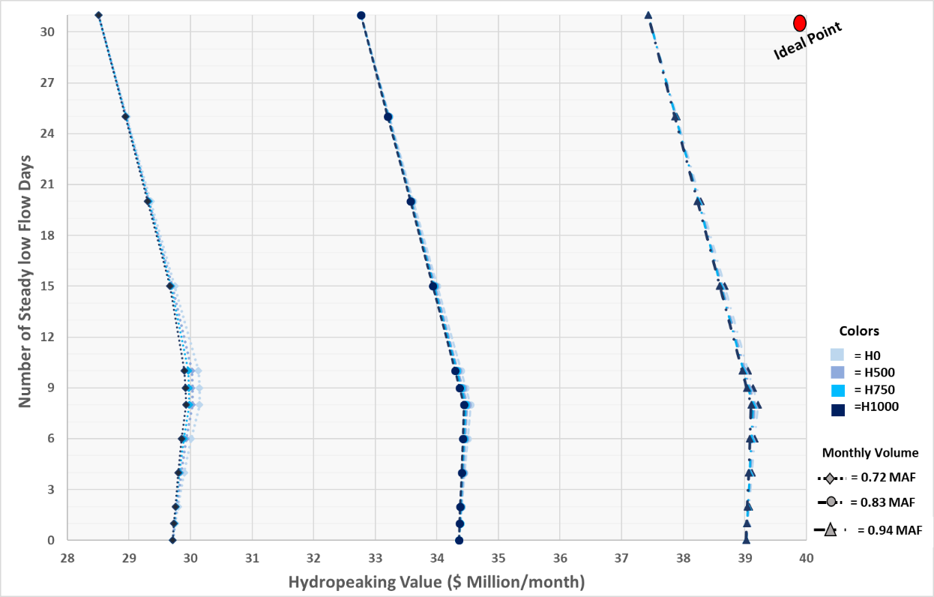
Fig. S11 Tradeoffs for four offset release scenarios (light to dark blue) and three monthly release volumes (marker shape) using the contract price model.
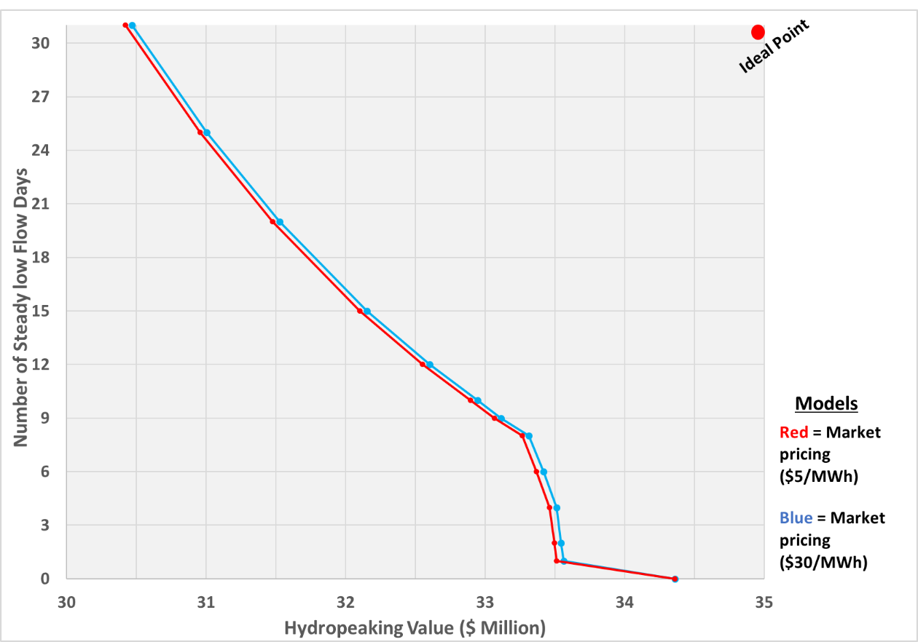
Fig. S12 Sensitivity of the price premiums ($5/MWh vs. $30/MWh) over estimated 2024 energy prices. Results correspond to August simulations with a 1,000 cfs offset release and a total monthly release volume of 0.83 MAF.
Table S6. Elevation change during the months of 2018 and change in hydropower generation. Negative values indicate a decrease; positive values indicate an increase.
Month | Elevation change (feet) | Change in energy production (MWh)
March | -3.7 | -32
April | -2.8 | -19
May | +2.3 | +19
June | -1.6 | -15
July | -6.0 | -46
August | -6.5 | -69
September | -4.6 | -34
October | -1.7 | -12
Text S7. Select sensitivity results with 2014 energy prices.
This section presents select sensitivity results using 2014 energy prices and compares those results to results that used 2024 estimated energy prices. We found tradeoff curves of hydropeaking value vs number of days of steady low releases had the same shape as curves for 2024 energy prices, but the x-axis intercepts (hydropeaking value with zero days of steady low releases) were shifted left or right depending on changes in weekday and weekend peak- and off-peak prices (Table S7).
Table S7. Cumulative loss of hydropeaking value ($ million) per number of days of steady low releases in 2018 with 0.83 MAF release volume, H1000 (offset release), and market prices of $5/MWh above 2014 contract prices. Losses are calculated relative to zero steady low-flow days (hydropeaking). Rows highlighted in blue indicate percentage losses.
Month | Value at zero steady days | Number of steady low flow days per month
 |  | 4 | 6 | 8 | 10 | 15 | 20 | 25 | 30 | 31
March | $19.9 | $0.35 | $0.40 | $0.45 | $0.64 | $1.04 | $1.37 | $1.64 | - | $1.91
 |  | 1.7% | 2.0% | 2.3% | 3.2% | 5.2% | 6.9% | 8.2% | - | 9.6%
April | $18.2 | $0.20 | $0.26 | $0.32 | $0.50 | $0.82 | $1.07 | $1.28 | $1.47 | -
 |  | 1.1% | 1.4% | 1.8% | 2.8% | 4.5% | 5.9% | 7.0% | 8.1% | -
May | $18.4 | $0.45 | $0.51 | $0.56 | $0.78 | $1.23 | $1.58 | $1.87 | - | $2.17
 |  | 2.5% | 2.7% | 3.1% | 4.3% | 6.7% | 8.6% | 10.2% | - | 11.8%
June | $20.1 | $0.31 | $0.37 | $0.43 | $0.68 | $1.16 | $1.47 | $1.73 | $1.97 | -
 |  | 1.5% | 1.8% | 2.1% | 3.4% | 5.8% | 7.3% | 8.6% | 9.8% | -
July | $25.3 | $0.70 | $0.77 | $0.85 | $1.16 | $1.84 | $2.35 | $2.77 | - | $3.21
 |  | 2.8% | 3.0% | 3.4% | 4.6% | 7.3% | 9.3% | 11.0% | - | 12.7%
August | $25.5 | $0.63 | $0.70 | $0.78 | $1.08 | $1.70 | $2.19 | $2.59 | - | $3.01
 |  | 2.5% | 2.8% | 3.1% | 4.3% | 6.7% | 8.6% | 10.2% | - | 11.8%
September | $23.6 | $0.23 | $0.30 | $0.37 | $0.60 | $0.95 | $1.25 | $1.51 | $1.75 | -
 |  | 1.0% | 1.3% | 1.6% | 2.5% | 4.0% | 5.3% | 6.4% | 7.4% | -
October | $21.8 | $0.42 | $0.48 | $0.55 | $0.76 | $1.23 | $1.60 | $1.91 | - | $2.22
 |  | 1.9% | 2.2% | 2.5% | 3.5% | 5.6% | 7.3% | 8.7% | - | 10.2%

Finally, we computed the change in hydropeaking value using the contract model for each additional day of steady low flow across various months in 2018 (Table S8).
Table S8. Change in hydropeaking value ($1000) per additional day of steady low reservoir release added in 2018 with 0.83 MAF release volume, and H1000 (offset release) for estimated 2024 and 2014 energy prices. Positive values show an increase; negative values a decrease.
Month | 2024 Energy Prices |  |  | 2014 Energy Prices
 | 0 and 4 steady low flow days | 4 to 8 steady low flow days | Above 8 steady low flow days | 0 and 4 steady low flow days | 4 to 8 steady low flow days | Above 8 steady low flow days
March | -$7 | -$7 | -$32 | $20 | -$1 | -$30
April | -$14 | -$14 | -$43 | $23 | -$1 | -$43
May | -$18 | -$18 | -$50 | $30 | -$1 | -$44
June | -$15 | -$15 | -$50 | $37 | -$2 | -$54
July | -$19 | -$19 | -$50 | $48 | -$2 | -$70
August | $10 | $10 | -$73 | $42 | -$1 | -$61
September | $2 | $2 | -$76 | $25 | -$1 | -$37
October | -$8 | -$8 | -$42 | $26 | -$1 | -$38

Text S7. References.
Bair, L., and Yackulic, C. (2024). "Predicted hydropower impacts of different management scenarios for Lake Powell releases." U.S. Geological Survey. https://doi.org/10.5066/P135BOD8
[LTEMP] Record of Decision for the Glen Canyon Dam Long-Term Experimental and Management Plan (LTEMP) Final Environmental Impact Statement (2016). https://ltempeis.anl.gov/documents/docs/LTEMP_ROD.pdf
Rind, M., & Rosenberg, D. (2026). Bugs Pay for Days of Steady Reservoir Releases to Reduce Hydropeaking-Ecosystem Conflict [Dataset]. https://github.com/moazzamalirind/BugFlowExperiment_Analysis2026.
USBR. (2024). Final supplemental environmental impact statement for near-term Colorado River operations. U.S. Department of the Interior. Colorado River Basin | Bureau of Reclamation https://www.usbr.gov/ColoradoRiverBasin/interimguidelines/seis/
[USBR] U.S. Department of the Interior Bureau of Reclamation, 2019. Glen Canyon Unit https://www.usbr.gov/uc/rm/crsp/gc/index.html
Yackulic, C., Bair, L., Eppehimer, D. E., Salter, G. L., Deemer, B., Butterfield, B. J., Kasprak, A., Caster, J. J., Fairley, H. C., Grams, P., Mihalevich, B. A., Palmquist, E. C., and Sankey, J. B. (2024). "Modeling the impacts of Glen Canyon Dam operations on Colorado River resources." https://pubs.usgs.gov/publication/70252976

